**Notification System of Picking-up and Dropping-off Students Via LINE Notify**

Phuttikorn Phatsadusan, Phitchaya Ngaopatcha, and Phapaporn Phuphalee

Science-Based Technology Vocational College (Chonburi)

37 Village No. 3, Ban Kao sub-district, Panthong district, Chonburi province 20160, Thailand

E-mail: 303kaw@gmail.com

**___________________________________________________________________**

**Abstract**

Tragic incidents of children dying from suffocation after being left in school buses due to drivers or teachers failing to check the vehicle after students have boarded or disembarked, especially young preschoolers who are unable to help themselves, have prompted researchers to develop LINE Notification for school buses. According to this issue, researchers have developed Notification System of Picking-up and Dropping-off Students Via LINE Notify. The objectives of this research were: 1) to develop Notification System of Picking-up and Dropping-off Students Via LINE Notify, 2) to test the efficiency Notification System of Picking-up and Dropping-off Students Via LINE Notify, and 3) to evaluate the user satisfaction with Notification System of Picking-up and Dropping-off Students Via LINE Notify. Researchers have developed Notification System of Picking-up and Dropping-off Students Via LINE Notify by using a Single Board Computer, a barcode scanner, and other components such as a Raspberry Pi 3B, a car’s power supply, and warning lights. The system consisted of three main parts: a server providing web applications and a database, a device control unit, and Notification System of Picking-up and Dropping-off Students Via LINE Notify. The effectiveness of the LINE Notification for school buses was tested by scanning student ID barcodes and sending notifications to parents for five days. The trial was conducted with students from a school in Phan Thong district, Chonburi province. A purposive sample of 10 individuals was selected for this study. The research instruments included a performance test and a satisfaction questionnaire. The researchers analyzed the data using mean and standard deviation. The hypothesis was the barcode scanner that it would have an accuracy rate of 80% or higher, and user satisfaction would be high. The results of the research concluded that Notification System of Picking-up and Dropping-off Students Via LINE Notify had an average accuracy rate of 90% and an overall average satisfaction rating of 4.38, which was considered very high.

**Keywords: Notification System, Picking-up and Dropping-off Students, LINE Notify**

**Introduction**

A tragic incident occurred when a preschooler was left unattended in a school bus and died from suffocation. The child, unable to help themselves, was overlooked by the driver or teacher after the other children had disembarked.

There is ongoing research into developing tools or devices to enhance student safety in school transportation, particularly to prevent children from being left behind in vehicles. While existing solutions, such as expensive safety equipment or driver training, have been implemented, parental concerns remain. Researchers are exploring the potential of utilizing everyday items, like student ID cards, to improve safety measures.

For this reason, researchers have developed Notification System of Picking-up and Dropping-off Students Via LINE Notify. This efficient and user-friendly system allows for the tracking of students on school buses or vans using barcode scanning of student IDs. Parents receive notifications whenever their children board or disembark the vehicle.

**Materials**

The equipment used to develop Notification System of Picking-up and Dropping-off Students Via LINE Notify.

1) A Raspberry Pi 3B: is a small computer board with more capabilities than a typical microcontroller. Due to its capabilities equivalent to a full computer but with all components on a single board, it is designed for computer education and the development of various electronic projects. It can be used for a wide range of applications such as learning to program, developing Internet of Things (IoT) projects, serving as a small server, controlling devices, and more.

2) Embedded Barcode Scanning Module: This is modules designed to be embedded within various devices for the purpose of scanning barcodes. These modules have the capability to read and decode data from various types of barcodes, accurately and quickly reading both 1D barcodes (such as UPC, EAN) and 2D barcodes (such as QR Code, Data Matrix).

3) Barcode: Barcode symbols, representing numerical data, consist of bars of varying thickness, corresponding to the numbers below. Data is read using light reflection principles, directly inputting information into a computer without the need for keyboard entry. This system is an internationally recognized standard used worldwide. Inputting data from product barcodes is a fast and reliable method, providing great convenience to users.

4) Siren: This device is designed to help in emergency situations. When an emergency occurs in a particular area, people nearby can easily see and hear the signal, enabling them to provide more effective assistance.

5) Piezo Buzzer: This is an electrical device that produces a sound when activated. It is commonly used in industrial settings and general buildings. When a button is pressed, the buzzer emits a sound. The sound stops as soon as the power is turned off.

6) LINE Notify: LINE provides is a service in the form of an API for developers to utilize and build projects that require sending notifications to personal accounts or groups.

**Methods**

Here are the steps Notification System of Picking-up and Dropping-off Students Via LINE Notify.

1. Analyze information about Notification System of Picking-up and Dropping-off Students Via LINE Notify.

2. Design our workpiece that consisted of two main components: software and hardware.

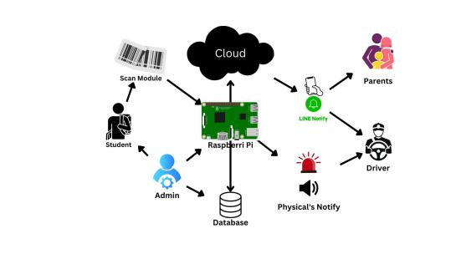

**Figure 1:** Design Notification System of Picking-up and Dropping-off Students Via LINE Notify

3. Test the efficiency of the innovation by conducting five trials Notification System of Picking-up and Dropping-off Students Via LINE Notify.

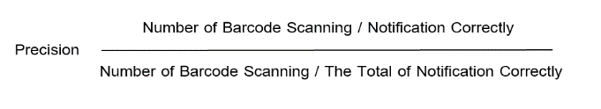

4. The system will be piloted with a selected group of users, and a user satisfaction questionnaire will be conducted that divided into two parts: structural design and system functionality.

**Results**

Table 1: Accuracy of Barcode Scanning and Notifications

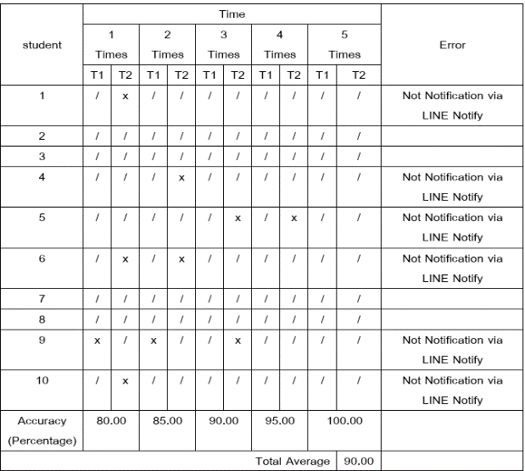

This test was conducted to measure the accuracy of barcode scanning and LINE Notify. The average accuracy rate was 90.

2) A satisfaction survey was conducted among 10 students and parents who used the school bus service. The average satisfaction score was 4.38 as high level.

**Discussion and Conclusion**

Notification System of Picking-up and Dropping-off Students Via LINE Notify system was developed to address the issue of students being left unattended in school buses and suffering from heatstroke. Its operation is divided into three parts: 1) a server providing web applications and a database, 2) device control, and 3) notifications. The system's effectiveness was tested by following a step-by-step procedure.

An evaluation Notification System of Picking-up and Dropping-off Students Via LINE Notify. revealed an average accuracy rate of 90 across barcode scanning, notification, and system operation. The system's performance was found to be contingent upon a stable internet connection, with occasional delays or failed Notification System of Picking-up and Dropping-off Students Via LINE Notify. A satisfaction survey indicated a high level of contentment among parents and students.

The user designed Notification System of Picking-up and Dropping-off Students Via LINE Notify. effectively addresses safety concerns for students and provides peace of mind for parents and teachers. Our group compared with other notification devices, this system offered the system that is easy to set up and use, and it sends alerts when something goes wrong. For example, a student is trapped in a car. The further enhance system, it is recommended to install GPS devices on school buses for real-time tracking, and to encrypt students' and parents' personal data to ensure privacy.

**References**

Kunaporn, W. (2017). *Development of Children-in-school Monitoring and Alert System.* Chonburi: Bachelor of Engineering Department of Electrical Engineering Burapha University.

Schoolbright. (2021). *School Management SystemAimed at transforming the school into a safe environment, instilling peace of mind for parents.* Retrieved from <https://www.schoolbright.co/>

Jongchana Bandum, Panokorn Sorin, Panopong Korau and Abhisit Thongdee. (2017). *Alert system when a child is trapped in the car.* Civil engineering soldiers, electronics Electronics School, Science Division, Naval Electronics Department. From https://elecschool.navy.mi.th/pro/doc65/12